

**Castle Hill Tennis Academy**

**Caterson Drive, Castle Hill NSW 2154**

**t. 02 9634 7504 m. 0415 445 035**

**playtennis@chta.com.au**

**www.chta.com.au**

## **School Holiday Tennis Camps**

**CAMP DATE: Mon 22nd – Wed 24th January 2018**

**9 am – 3 pm**

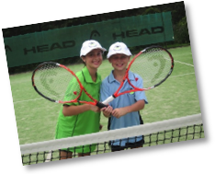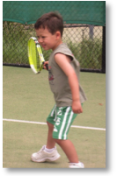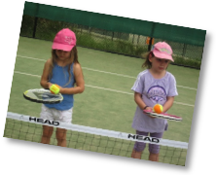

|  |  |  |  |  |  |  |  |  |  |  |  |  |  |  |  |  |  |  |  |  |
| --- | --- | --- | --- | --- | --- | --- | --- | --- | --- | --- | --- | --- | --- | --- | --- | --- | --- | --- | --- | --- |
| |  |  |  |  | | --- | --- | --- | --- | | ⚫ | Tennis NSW Accredited coaching program to suit all ability levels from beginners to advanced | ⚫ | Ideal ways to improve tennis skills, keep active, make new friends and have lots of fun! | | ⚫ | All tennis strokes taught, set play (singles & doubles), drills and games | ⚫ | Lunch provided on the last day of Camp (lunch, drink and snack) | | ⚫ | Suitable for children from  5-14 years | ⚫ | Tournaments will be played in all divisions | | ⚫ | Children will be well supervised at all times | ⚫ | Trophies and prizes awarded at each Camp | | ⚫ | Attendance wet or fine | ⚫ | Parents are invited to attend trophy and prize presentation on the last afternoon of Camp | |



Child's Name: _______________________________

Address: ___________________________________

_______________________________ Age: ______

Parent Name: _______________________________

Tel: _______________________________________

Email: _____________________________________

Allergies / Special diet / needs: ______________________________

**Prices:**

Full 3 Day Camp: $ 110 9am-3pm

Single Day Rate: $ 40 9am-3pm

Half Day Rate: $ 30 9am-1pm

**Camp Dates: Mon 22nd – Wed 24th January 2018**

**BOOKINGS ESSENTIAL**

(Please select from options below):

**Full 3 Day Camp** (9am-3pm daily): ..................❑

**Or:** **Single Full Days** (9am-3pm): .................................❑

___ Days: M❑ T❑ W❑

**Or:** **Half Days** (9am-1pm): ..............................................❑

___ Days: M❑ T❑ W❑

**Total payable:** $____________

Preferred payment methods: Cash, EFT or Direct transfer to:

BSB 062 347 Account No: 10 088 790

To make your booking please complete form and submit by email to: **Castle Hill Tennis Academy**

**Caterson Drive Castle Hill 2154**

**Email to: playtennis@chta.com.au**

Office use only

Receipt No. _________________ Date: ___________________



**Application Form**